Media Library Documentation
The NC AHEC Web Services platform has been created in an effort to supply web application support for NC AHEC regional operations.
Each application is built collaboratively with contributions from AHEC regional partners.
Some applications require the user to sign in. Some applications are open and available to all users.

Log-In and Access
A user may access their account by logging-in to the following URL: https://stage.easternahec.net/sign-in.
If a user already has a MyAHEC account, they may use it to log-in. Otherwise a user may create an account.
Once logged-in, a user will view their applications on the NC AHEC Web Services Dashboard at https://stage.easternahec.net/dashboard.
If you have any issues logging-in, please feel free to contact the Program Office at info@ncahec.net for support.
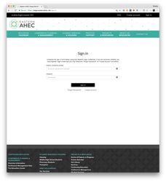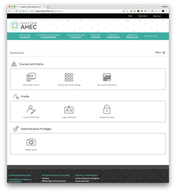

Courses and Events Catalog
The Courses and Events Catalog may be accessed at https://stage.easternahec.net/courses-and-events or by selecting the "Courses and Events Catalog" icon on the Dashboard.
The Courses and Events Catalog is accessible to everyone; however, if a user is authorized to create and edit courses for their region, they will have access to additional administrative features.
One of these administrative features is the ability to select which images are displayed with courses in the Courses and Events Catalog.
It is not possible to upload an image using the Courses and Events Catalog administrative features.
Images are only uploaded using the Media Library.
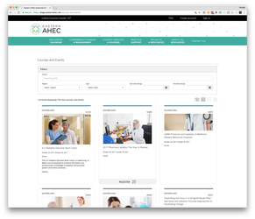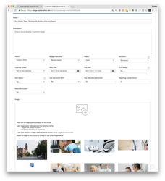

Media Library
The Media Library has been created to allow AHEC marketing professionals across the state to manage their region's online image assets.
Presently, these images are primarily focused on the courses and events per region that are displayed in the Courses and Events Catalog.
A user must be authorized to view the Media Library. When authorized, a user will see the Media Library icon on their Dashboard. If you do not have access to the Media Library icon on your Dashboard and feel you should, please contact the Program Office at info@ncahec.net for support.
Once open, a user may view all the images for their region as well as statewide image assets. By default, regional images are shown first and statewide images are displayed after regional images.
There is a title search filter along with drop-down filters for Region, Budget Discipline, Keywords and Autofill tags. You may also use the Region filter to see only statewide images. Simply select the "NC AHEC" option.
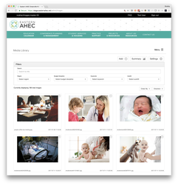

Adding Images
Images may be added by selecting the "Add" button in the top right corner of the Media Library application.
Once in the Add Images view, a user may drag and drop image files or click on the camera icon to browse and select image files from their computer.
Before uploading an image to the Media Library, it is mandatory that the user have the right to use and distribute the image for commercial purposes. For this reason we ask the user to indicate the Source of the image or images they are uploading.
Once an image or multiple images have been selected, a user will be required to enter the Source of the image. It is essential that all images uploaded to the AHEC Media Library be approved for commercial redistribution.
A user may also tag the image(s) with the desired Region, Budget Discipline, and/or Keywords. Keywords may be used to filter image results in the Media Library as well as the Edit Course form in the Courses and Events Catalog.
With the Autofill option, a user may also select whether or not the image(s) to be uploaded will be used to populate courses which are not assigned a specific image. If the image(s) being uploaded are general in nature and could potentially be used for more than one course, the answer would be “Yes.” If the image(s) to be uploaded apply specifically to a certain course or courses the answer would be “No.” Similarly, if the image is being saved in the Media Library for a use other than the Courses and Events Catalog the answer would be “No.”
Complete the image upload by clicking the "Upload" button.
Once the upload is complete, a user may go to the image detail page by clicking on the image.
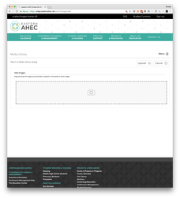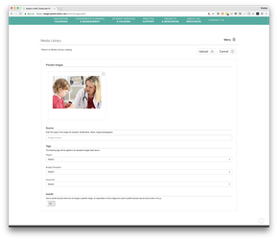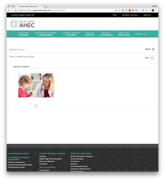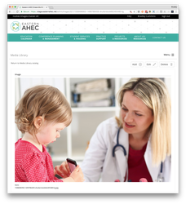

Viewing Image Details and Editing
A user may view an image's details and edit image details by selecting the image from the Media Library.
On the Image Detail page, a user will find the tags being used for the image. The courses affiliated with the image will also be found on the Image Detail page.
If a user is authorized to edit a particular image, they will find the "Edit" button in the top right corner of the Image Detail page.
Only users authorized to edit statewide images will be able to edit statewide images.
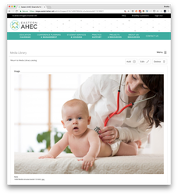

Tagging Images
In addition to designating regional ownership of an image, tags are used to auto-populate images for courses in the Courses and Events Catalog that have not been assigned a specific image.
Tags are also used for searching and filtering images in the Media Library and Courses and Events Catalog.
For example, if an image is tagged with the keyword "Children," the Media Library may then be filtered to show all images with the "Children" keyword.
Image tags may be edited by selecting the "Edit" button.
Only users authorized to edit statewide images will be able to edit statewide images.
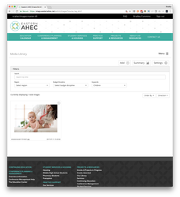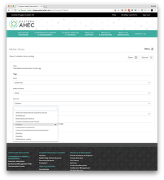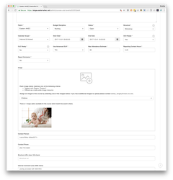

Assigning Images to a Specific Course or Courses
Within the Media Library on the edit page in addition to the Region, Budget Discipline and Keywords, an image may be assigned to a specific course or courses.
When an image is assigned to a specific course or courses, that image will be used in the Courses and Events Catalog for each of the designated courses.
If the Autofill image option is set to "Yes," the image may also be used to auto-populate courses that are not assigned a specific image.
If a user would not like the image to be used to auto-populate courses that are not assigned a specific image, the Autofill image option should be set to “No.”
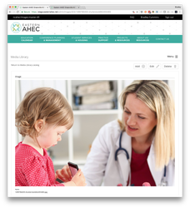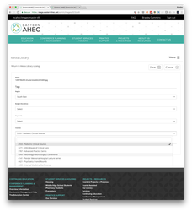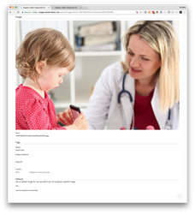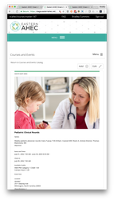

Summary View
In the top right corner of the Media Library, a user will find the "Summary" button. The Summary view details the breakdown of the user's courses and events and whether a specific image is being applied to the course or if the course's image has been assigned with the Autofill feature.
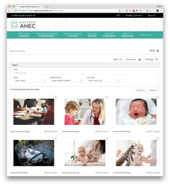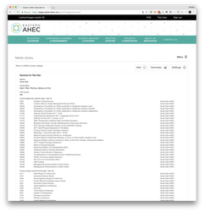

Settings View
In the top right corner of the Media Library, a user will find the "Settings" button. The Settings view details how images are assigned to courses that have not been assigned a specific image.
The Settings View also allows the user to reset the Autofill course images. The process removes auto-populated images from courses that have not been assigned a specific image and reassigns images to these courses depending on the criteria defined in the "How Autofill Course Images are Assigned" list.
